# Automatic batch files creation for dropping all HM unit tests.

## How to create them?

Simply copy the “CreateBatchHMDrop.py” file in the root folder of all the HydroCalc unit tests:

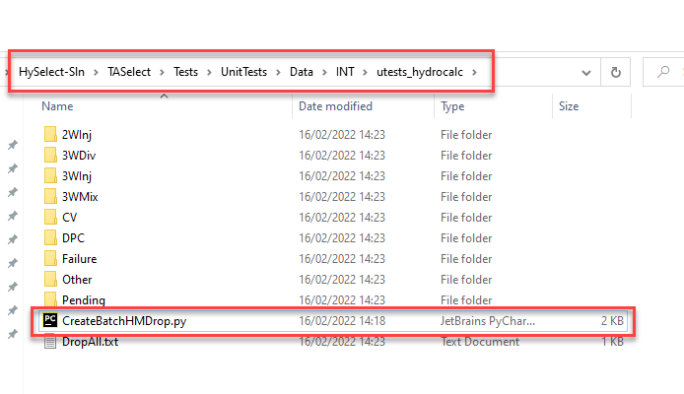

Now go in this folder with a command DOS prompt and type following commands:

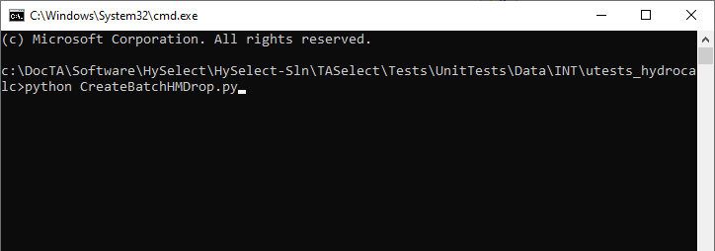

Of course, you must have a python interpreter installed and the “python.exe” access defined in the “PATH” variable system environment.

In the main folder, you normally have the “DropAll.txt” file. And in each subfolder, you must have a file named “DropAllXXX.txt” where “XXX” is the subfolder name:

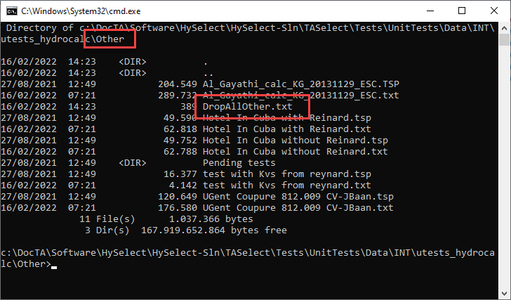

## How to use them?

It can happen that sometimes, after a major change, we need to drop again all the HM unit tests from the equivalent .tsp files.

It can be done for only one folder or all folders.

### One specific sub folder

Launch HySelect in debug mode and in the “Home” ribbon, click on the “Special actions” button in the “Tools” group. And once the “HySelect Special Actions” dialog is opened, go in the “Testing” tab, and click on the “Batch-SnapShoot” button:

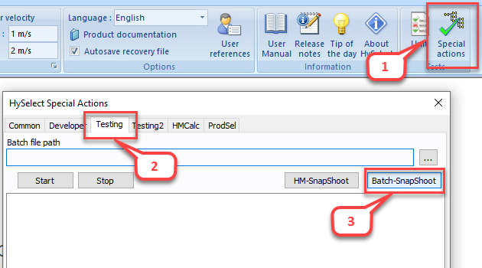

For example, choose the “DropAllDPC.txt” file from the “TASelect\Tests\UnitTests\Data\INT\utests_hydrocalc\DPC\” sub folder of the HySelect solution:

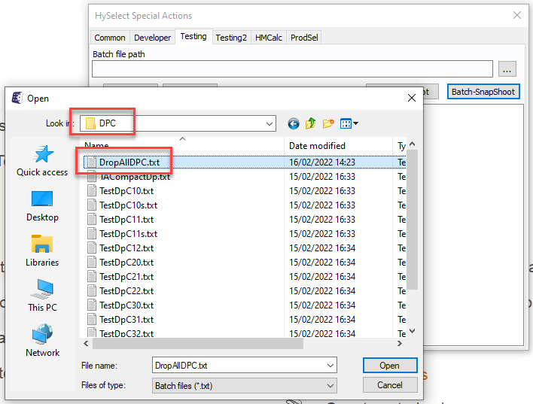

And wait that HySelect runs the drop of all the project file in this folder:

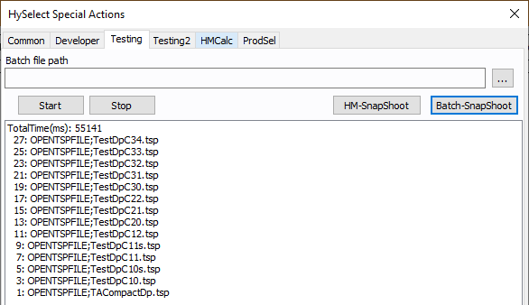

### All sub folders

For the batch file, choose “DropAll.txt” in the root of the “utest_hydrocalc” folder:

